Getting started with Thingspeak:, Teil 1:
https://www.youtube.com/watch?v=ZayVoLxeRq4&t=82s

Video zu Pico W and Thingspeak:
https://www.youtube.com/watch?v=9VCL8igwuPA
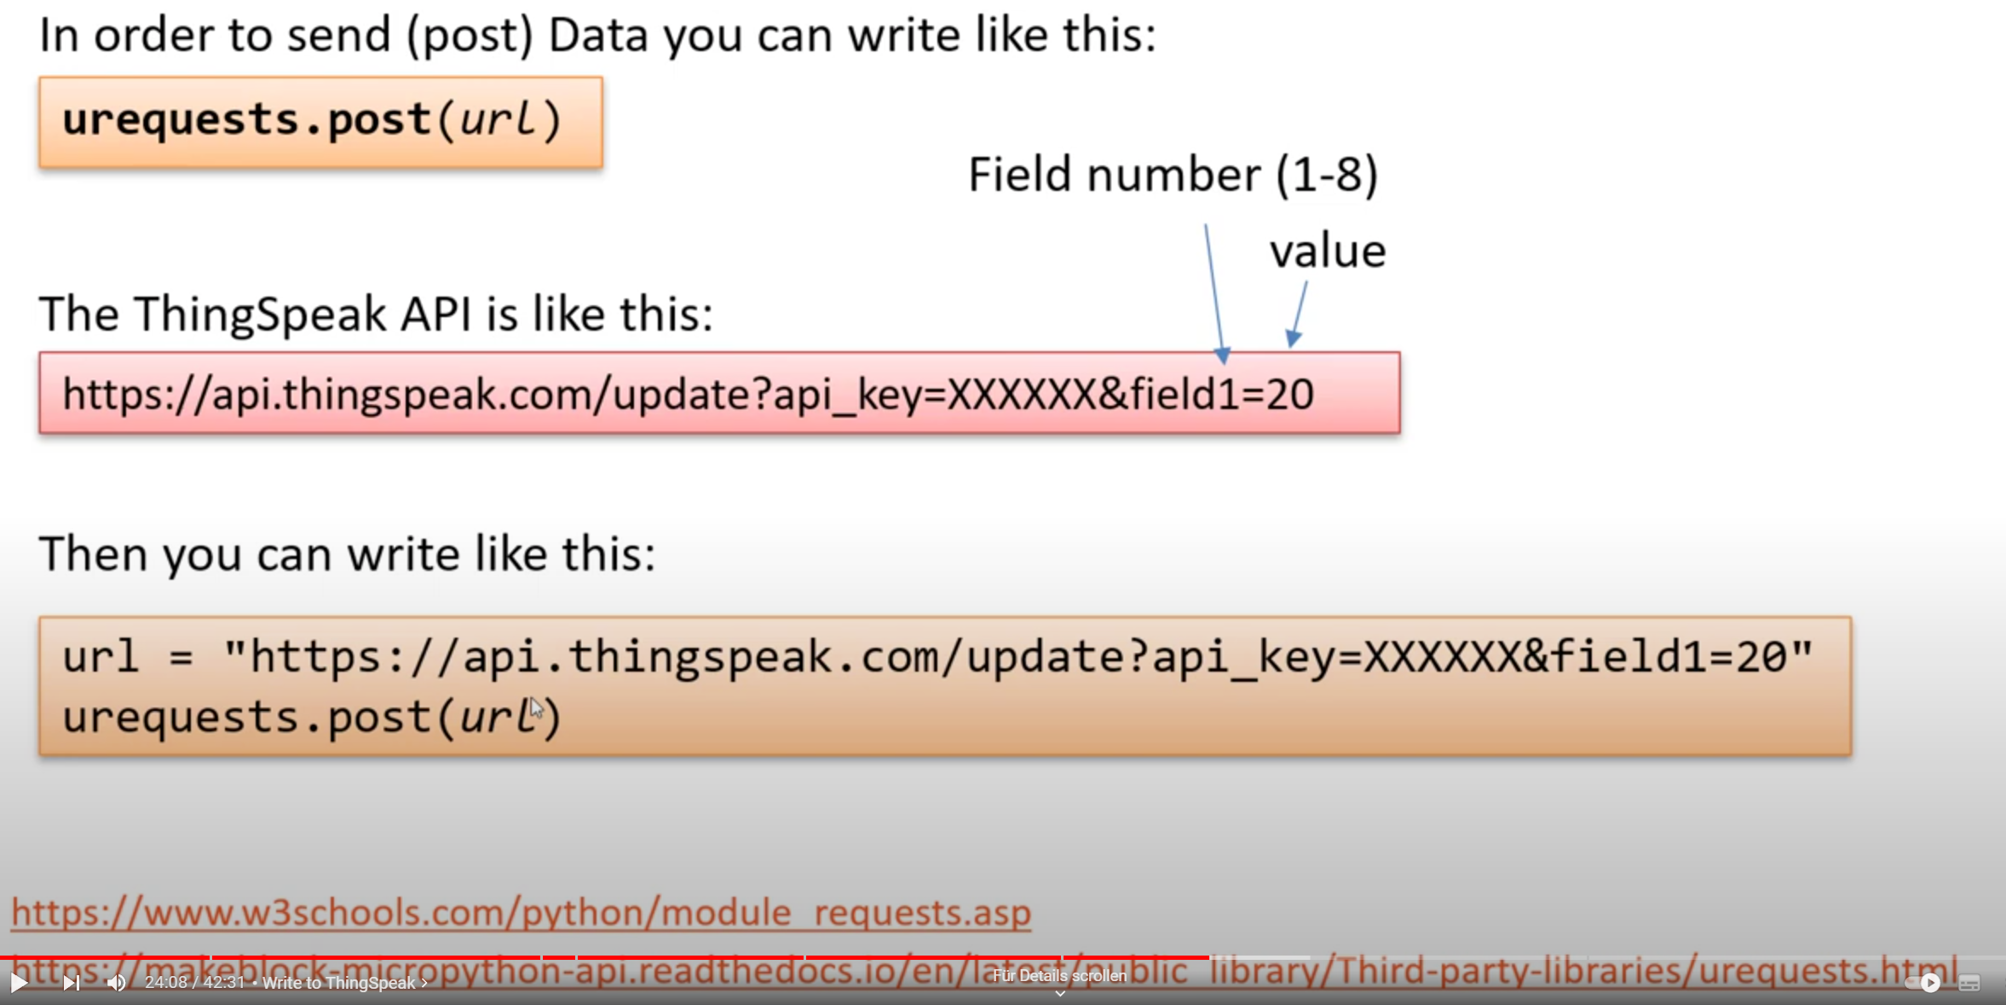

How to analyze IoT-Data in Thingspeak, von Matlab selbst:
https://www.youtube.com/watch?v=y5PoByl4LgA

